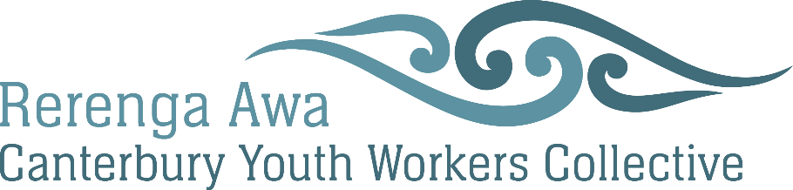

Rerenga Awa | Canterbury Youth Workers Collective
Annual General Meeting
Wednesday 30th August 2023 12:30 pm - 02:30 pm
Christchurch City Mission
275 Hereford St, Central Christchurch
Christchurch, New Zealand

Present: Zenn Rarere (YCD), Daniel Mataki (YCD), Trystan Swain (Youthline), Natalia Sukhith (Rerenga Awa), John Harrington (Scope), Richard Chambers (Youthtown), Tyler Ngatai (Ara Taiohi), Jenn Chowaniec (WFCT), Jess Benson (WFCT), Kris Heslin (Te Whatu Ora), Luke Gardiner (24-7YW), Lara Moses (CCC Libraries), Hamish Flynn (PYDT), Jeremy Adams (PYDT), Matt Meek (Riccarton Community Church), Susan Ward (La Vida Youth Trust), Chris Martin 4YP, Lauren Tennant (Odyssey), Lydia Newlands (Kaitiaki o Ara), Lina Leitare (Diamond Harbour YCT), Angelina Tivalu, Cynthia Webb (Youthline), Amanda Murray (Odyssey), Hannah Dunlop (Rerenga Awa), Sarah Millar (Kawai Rangatahi), Jacey Goldfinger (Rerenga Awa), Tim Perry (Rerenga Awa)

Apologies: David Du Preez- Youth Alive, Mike Dodge- CYS, Kevin Grimwood current treasurer, Michelle King- YCD, Jo Sherwood- Hurunui DC, Amanda Smith- TOHO, Cooper Sides.

- 12.35pm- Blessing and Karakia – Zenn

- Get Kai and Drink

- Welcome & Whakawhanaunga – Tim Perry, Manager
- inc. Notices- Reminder of Vision
- Apologies:

- Guest speaker- Tim- City Mission
Tim shared the range of services City mission do including the café and new format of food bank which is more like a supermarket.
Questions were asked about the night shelter and any good stories from around the mission. Tim shared lots of great stories of people finding help, and hope and community around different aspects of the mission.

- Chairperson’s Report – Amanda Murray, Chairperson
Amanda shared report as a Limerick
- Treasurer’s Report – Kevin Grimwood, Treasurer – Tim shared written report and highlighted key points.

- Managers’ Report - Tim Perry, Manager
Tim shared report as a poem
Chairpersons report, Treasurers report and Managers report are accepted
Moved: Luke Gardiner Seconded: Lara Moses All agreed
- Minutes of 2022s AGM – Tim Perry
Minutes from 2022 AGM are true and correct
Moved: Richard Chambers Seconded: Daniel Mataki All agreed

- Membership- Tim Perry
We are in process of moving membership platform; everyone should have or will receive an email to change over to the new platform.
We currently have 110 Active & prospective Members including 20 organisations.
150 inactive members- people who haven’t renewed their membership - over the next year this will be tidied up. This is down from over 300 last year as we tidy up the platform.
FYI: There have been changes to the act that governs incorporated societies re write of constitution.

Resolution: The membership agrees to allow the Board to set set membership fees for the coming year.
Moved: Richard Chambers Seconded: Angelina

- Elections
Nominations have been collected prior to today, is there anyone else wanting to put up their hand?- No extras.
Names put forward for nomination are:
Current board members standing again: Richard Chambers, Lara Moses, Amanda Murray, Amanda Smith, Sarah Millar, Michelle King, Lydia Newlands Kevin Grimwood
New to the board Nominations: Kris Heslin, Jo Sherwood.
All present agreed to the new committee via a show of hands. The committee for 2023 is: Richard Chambers, Lara Moses, Amanda Murray, Amanda Smith, Sarah Millar, Michelle King, Lydia Newlands Kevin Grimwood, Kris Heslin, Jo Sherwood
- General Business
Any questions?- no questions were asked.

- Discussion on Advocacy- Tim
As part of our strategic plan from the board was to look at what we advocate on.
I have been thinking more about it with elections coming up and seeing YP as political footballs.
In groups people wrote down what they felt were important issues that collectively we should advocate on.
Feedback from groups:

For the Voice of Young People to be heard
Processes & support for all youth workers- voluntary or Paid
‘Youth Worker’ recognition
Accessible training
Equipping + training of Voluntary youth workers
2.
Youth not attending school
Schools not equipped to deal with rise in use of aggression and social media
What is/what should be:
Youth workers role when…
Things aren’t going well.
PYD- use what works
Social Media
Young People on Board
3.
Law of voting age- Make it 16 campaign
Push the Pledge Ara Taiohi have
Good conditions for youth workers
Security of long term funding
Well targeted social spending
Sustainability of profession.
4.
Community development
More representative youth voice- not manipulated
Pathways back into mainstream- truancy, crime, disengagement
Youth Crime interventions
Cost of Living
Health + wellbeing
5.
Positive responses to young people
Boot camp
Punishment/deficit mindset
Longer commitment to time, money for real change
Advocating for – sustainable funding
-Retaining employees
-Young workers retained
Youth work seen as lower
Fighting for change
Youth spaces and places
Intergenerational theft

- Karakia – Closing of Formal Meeting- Zenn

